Practical - 12
Practical Title : Event Management CRUD with Poster Upload and File Validation
Problem Definition: Develop event management functionality for admin users. Admin can add, view, update, delete, and upload event posters with file type and file size validation.
Theory
- Are add, update, and delete functionalities implemented correctly?
Answer: Add, update, and delete functionalities are implemented to manage event records.

- Is the UI linked with the database correctly?
Answer: The UI is connected to the MySQL database using PHP.

- Are poster uploads validated for type and size?
Answer: Poster uploads are validated for file type and size.

- Are success and failure messages displayed?
Answer: Appropriate success and failure messages are displayed for each operation.

Implementation :
- Implemented add, update, and delete functionalities to manage event details.
- Connected the user interface to the MySQL database using PHP.
- Added poster upload validation to check file type and size.
- Displayed success messages after successful operations.
- Displayed error messages when an operation fails or invalid data is entered.

Evidence of Work (Screenshots)
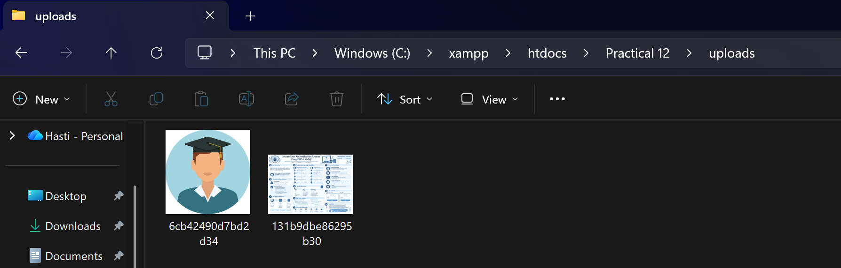
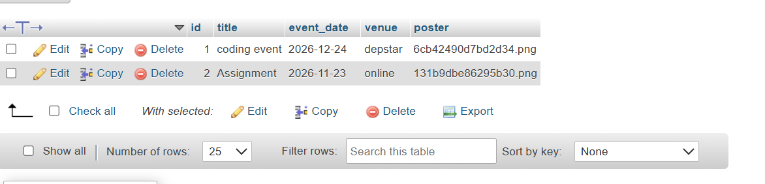
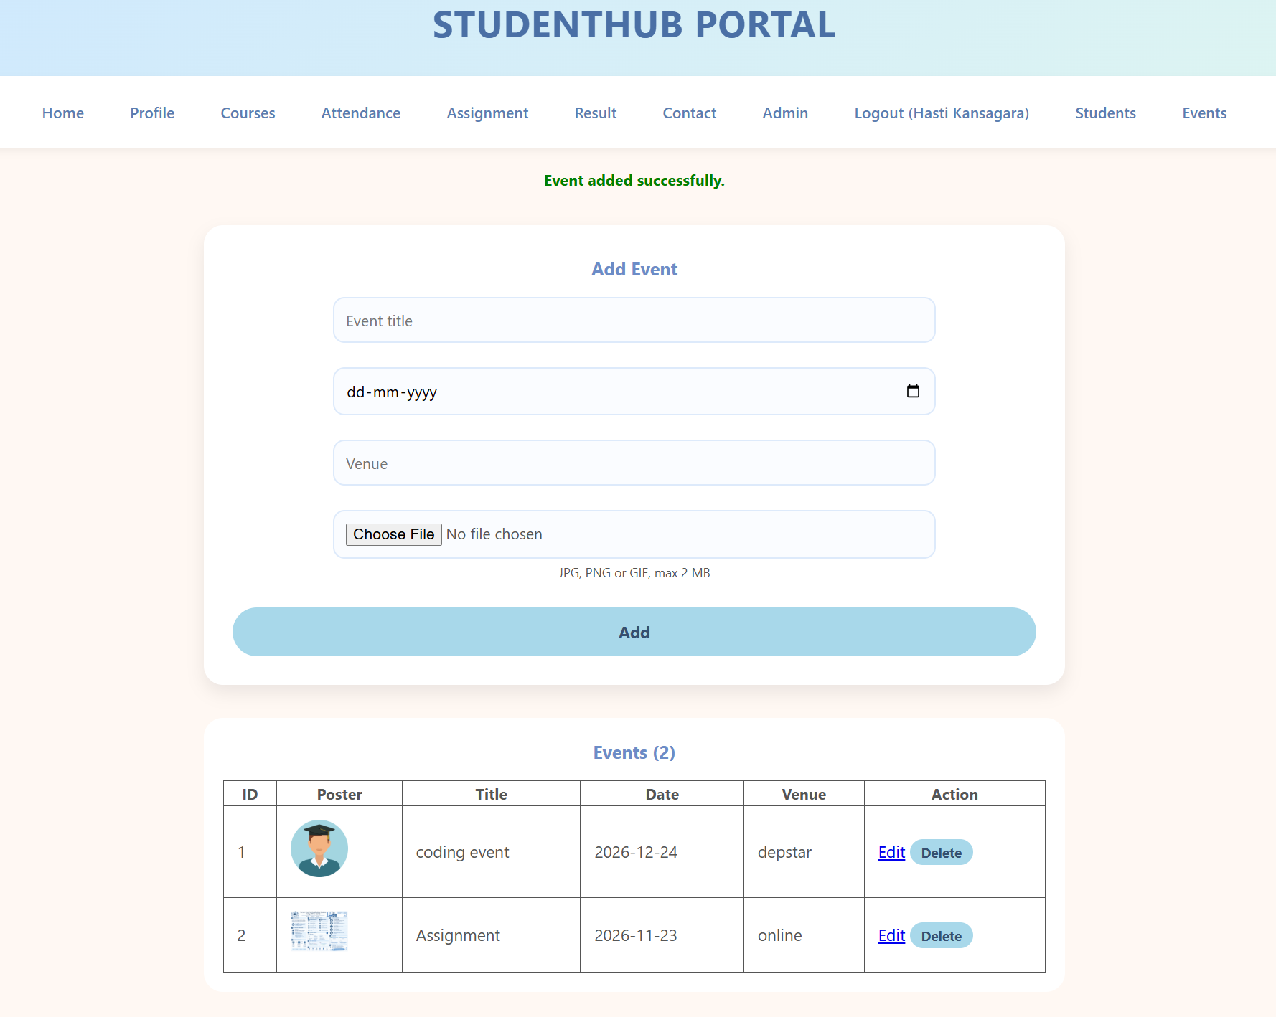

GitHub Repository Link:
https://github.com/kansagarahasti24/WDF

Challenges Faced:
- Connecting the event management UI with the MySQL database.
- Implementing add, update, and delete operations correctly.
- Validating poster file types and sizes during uploads.
- Handling file upload errors and database operation failures.
- Displaying appropriate success and error messages to users.

Learning Outcomes:
- Learned to implement CRUD operations for event management.
- Understood how to connect the UI with a MySQL database using PHP.
- Learned to validate poster uploads based on file type and size.
- Gained experience in handling errors and displaying success messages.
- Improved understanding of database management and file upload security.

Faculty Remarks: (Keep this blank for faculty)

